"Managing Gen Z"

You're gonna want to hear this one.

Zoe's avatar

[Zoe](https://substack.com/@zoeffc)

Jun 06, 2025

[1](https://femmefuturescooperative.substack.com/p/managing-gen-z/comments)

1

Share

Dear Reader,

Did you know that there is a course available through LinkedIn Learning dedicated to teaching managers how to work with their Gen Z colleagues? When I came across it this morning, I had the immediate desire to send it to some of my awful former managers — but, I stayed strong for the sake of my career, and decided that I would sit down and watch through it.

It is taught by Watchen Nyanue Hampton, the self-proclaimed “Gen Z Whisperer” and founder of “I Choose the Ladder”, a boutique consulting firm focused on women-centric HR. On her Instagram, she discusses how she created the “college to career” newsletter, but I couldn’t find it anywhere. She seems well-intentioned, but I really don’t know what qualifies her (or anyone else) to discuss how to manage an entire generation of people through and ill-fitting stereotype.

She isn’t the only one trying, though. LinkedIn Learning has several other courses on this, like this [one](https://www.linkedin.com/learning/managing-generation-z/gen-z-unlike-any-you-ve-managed?u=77842946), or this [one](https://www.linkedin.com/learning/understanding-the-gen-z-perspective-as-a-manager/create-an-inclusive-workplace-for-gen-z?u=77842946), or this [one](https://www.linkedin.com/learning/attracting-hiring-and-working-with-gen-z/understanding-the-gen-z-mindset?u=77842946). TED has also tapped into this niche as well as a whole slew of men with microphones, a.k.a. productivity podcasters.

On one hand, I can see the point of videos like this — everyone looking these up has the best intentions. It isn’t hard for me to picture a kind, well-meaning Gen X or millennial manager starting to work with a younger colleague, struggling with some of the cultural differences, and then going to the internet to see what advice there is out there. What gets me though, is this stereotype of Gen Z that they are met with.

Don’t get me wrong, I am biased — I think that Gen Z is a generation of thoughtful, kind, progressive, world-changers. That’s why I write these newsletters. So you can imagine my surprise when Watchen tells me that Gen Z don’t know how to critically think or how to listen.

You think that the generation raised surrounded by the ubiquitous use of therapy language doesn’t know how to *listen?* I am flabbergasted.

Clearly, I watched Watchen’s course all the way through, and I have notes.

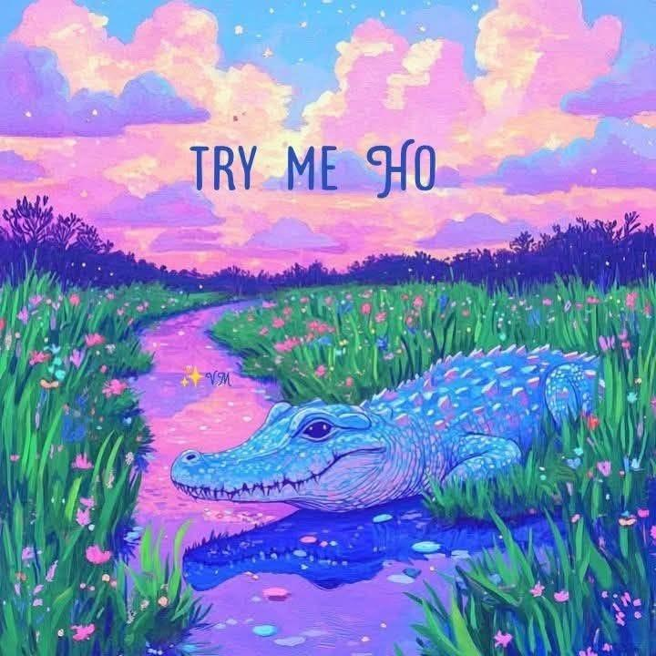

Before I go any further — lets do the housekeeping.

First, if you are not already a subscriber and you resonate with any of the following descriptors, consider joining the cooperative: (1) Early-career professional; (2) Feminist; (3) Do-gooder; (4) Former Gifted Kid; (5) Overachiever; or (6) Capitalism-hater.

Subscribed

Second, if you like what I am saying and it makes you think of someone in your family/office/friend group, send it their way.

[Share Femme Futures Cooperative](https://femmefuturescooperative.substack.com/?utm_source=substack&utm_medium=email&utm_content=share&action=share)

Third, I say some personal and vulnerable shit every week. Say some vulnerable shit back. It’s called a community.

[Leave a comment](https://femmefuturescooperative.substack.com/p/managing-gen-z/comments)

Okay — back to it.

For those of you who have not spent any time on LinkedIn Learning, it is a professional development resource that you can pay for to access classes taught by… random people? My organization pays for it, and I have found some helpful classes on Excel and AI for project management. Structurally, courses are a series of short videos broken down by subtopic, each about a minute to three minutes long. Watchen’s course is specifically called “Nano Tips for Closing the Soft Skills Gap with Gen Z”, so it is no surprise that her videos are all between a minute and a minute and thirty seconds long. It’s digestible, but ironic given some of her arguments.

My plan here is to go through each of her micro-videos and give you my thoughts.

**Professional communication: Teach them to talk the talk**

Watchen explains to viewers that Gen Z doesn’t know what professionalism is because we were raised on memes, voice-notes, and status updates. While I don’t necessarily follow that particular logic, I can agree that I did need to actively learn corporate communication styles. So does everyone who walks into a new corporate environment though, this is not unique to Gen Z or our media diets.

I give this point 3/5 - it’s a fair general point that professional communication is a skill that must be taught, but this isn’t unique to Gen Z or caused by memes.

**Critical thinking: Push for thought, not just answers**

Watchen’s opening line is, “The reality is that for most of their lives, Gen Z has been told what to think and not necessarily how to think.”

Watchen, I do not know how you arrived at this conclusion.

Gen Z has existed in a media ecosystem that bombards us with more information than we know what to do with. Everyday, we are asked to take in information, assess it for truth, and then react to it. We have complex thoughts and ideas on much of the media we consume and are capable of critique of even our favorite shows, authors (I am looking at you JK Rowling and Neil Gaiman), and politics. While I am on the topic of politics, it feels apt to point out that it is not Gen Z who are falling down the misinformation pipeline to alt-right extremism. What is more, social media is a platform that begs for public debate — a form of communication only possible with critical thought and the ability to listen, comprehend, and respond to an alternative point of view.

Additionally, in the US, Gen Z was the generation of public school students impacted by the change in our educational curriculum (referred to as “the common core”) that emphasized critical approaches to subjects like math. Students are still being taught to ask why 7x3=21 and not blindly accepting it because it was written in a times table — something that older generations struggle to understand.

I give this a 1/10. I am truly baffled at how someone could end up with Watchen’s opening conclusion.

**Managing up: Coach them to help you help them**

The phrase “managing up” triggers me. I have had managers use it as a way to scapegoat me for them being irresponsible, underprepared, or poorly behaved.

However, Watchen does well on this one in my opinion. Managing up, much like professional communication, is a skill that must be taught. While I have had managers use the term “managing up” to mean that I need to not let them make mistakes, Watchen describes it more as the ability for the managed person to proactively assess the needs of their manager and be able to adequately discuss pain points with them. This version of the skill is what takes an employee from average to excellent. It relies on a deeply synchronized team-dynamic that is defined by trust and respect. In order to get your employee to read your mind, you have to trust them with information and situational knowledge, and give them the space to make mistakes as they attempt to learn this skill.

Managee, it is not your job to keep your boss from making an ass of themselves. It is your job to make their job easier.

I give this an 4/5.

**Workplace etiquette: Explain the unwritten rules**

The argument here is that because Gen Z has often only experienced hybrid or remote work, we haven’t gotten the chance to observe how our professional community works on a day-to-day basis, from the clothes that they wear, to the way that they walk into a room, to how they run meetings.

My rebellious counter-argument here is that we quite literally don’t live in that world anymore. Full-time in office etiquette is outdatted and while I am sure that it is jarring at times to see it disrupted, I hope that my Gen X and millennial colleagues have the wherewithal to ask why we do things that way and if the change is that egregious.

For example, on a work-from-home day, is it appropriate to not wear professional attire? In some cases, it *would* be inappropriate to get on a call in a hoodie or a tee-shirt, but in other cases, it really doesn’t matter. Gen Z are learning these nuances just as everyone else is.

I fit this profile of a Gen Z who has never worked in office full-time. Despite that, I have been able to learn two different workplace cultures that are tangibly different post-pandemic than they were pre-pandemic. However, if anyone wants to spell the rules out for me explicitly, I certainly will not stop them — it is easier for everyone that way.

I give this 3/5 — it’s harmless but also lacks critical thought.

**Navigating ambiguity: help them work without a roadmap**

You cannot tell me that the generation who navigated the COVID-19 pandemic as high school and college students doesn’t know how to navigate ambiguity.

Watchen argues that Gen Z has always had the ability to google a solution, so we aren’t good at not having clear instructions. I will concede that we do prefer clear instructions. However, we also know how to google things, so if our bosses don’t give us clear instructions, there is a good chance that we know how to find those.

As a generation that was raised in the most turbulent times the US has seen in likely 100 years, Gen Z has had to navigate challenges that no-one has navigated before. We may not like ambiguity, but we certainly know how to deal with it.

I give this 2/5.

**Conflict resolution: Don’t let them ghost problems**

Apparently when Gen Z is confronted by conflict, our reaction is to “block” or “mute” and walk away. Truthfully, I am of two minds on this one.

On one hand, I can see where Watchen is coming from. Gen Z is a generation that is firm on boundaries to the point of walking away. We are the “protect your peace” generation and that does result in walking away from a conflict instead of addressing it. However, both the notion of boundaries and “protecting your peace” are products of the dialogic transition to therapy speak that our culture has undergone in the last 10-20 years. Part of being a more therapized generation is the ability to navigate hard things like conflict in a way that is healthy and productive.

I think that it can be helpful for managers to demonstrate healthy approaches to conflict in the workplace, but we shouldn’t assume that Gen Z is coming in with none of these skills. I give this 3/10.

**Time management: Help them juggle it all**

This is another age-old question: how do managers teach time management to young employees. Watchen points out that this is not unique to Gen Z, which I appreciate. It is also a hard skill to learn.

I give this a 4/5 — we all need to be better at time management.

**Handling stress: Teach them to cope, not quit**

Let’s go back to the note about ambiguity, the note about critical thinking, and the note about conflict management. Gen Z came of age during a global pandemic, the social media age, and a cultural shift towards therapy speak. We may have some experience navigating stress. However, this is another one that I feel Watchen handles alright. She immediately notes that Gen Z is incredibly capable of identifying their feelings of stress or burnout, though we are less equipped to navigate it.

Having spent a lot of my time reading and thinking about burnout, I want to note that it is not a term that was used 20 years ago despite how normalized it feels these days. It seems to me that as older generations, specifically millenials are reaching the mid-poitns of their careers, they are reflecting on their approach to work and realizing that they have been chronically stressed for years and it is leading to burnout. Their reflection in public forums has lead to the popularization of this term and of thinking about how we manage different types of stress. I point this out to say that *no-one* knows how to manage stress when they are young and *everyone* needs good role models, tools, and support.

Watchen also advocates for these things and goes a step further to suggest tangible ways that managers can offer tools and support to their Gen Z employees. One suggestion she makes is for managers to cue their employees in on stress-cycles during the year. In every job, there are periods of high-stress and then periods where that eases back a bit. People with more experience in the organization will know that better than the fresh-blood will.

I give this 5/5. Well done, Watchen.

**Active listening: Get them to listen to understand**

Watchen makes the classic argument that the TikTok generation cannot focus long enough to listen. I agree that the shortening of the content that we consume is impacting our attention span and that is something that needs to be addressed. However, we sat in classrooms just like everyone else and were taught how to listen and learn. We have long and complex conversations and engage in intellectual debates — activities that require listening, comprehension, and critical thought.

In the back of my mind, I worry that Watchen might be right here. I know that I don’t do well with a lot of information all at once and can feel when my brain stops absorbing things. While I don’t think that this is necessarily specific to Gen Z, I think that we were not set-up for success in this area because of the nature of our media consumption.

In the case of listening, I think that both managers and managees have work to do. Everyone is aware of their limited attention spans and many people are working to address that. We also need to be reflecting on the best ways for each of us to consume information and how we can work together to ensure that the material is understood.

Watchen, I concede on this one — 4/5 because I am a sore loser.

**Understanding hierarchies: Teach them to read the room**

I still don’t understand the value of hierarchies. That does not mean that I don’t recognize them or cannot navigate them. I think that they are stupid and antiquated and I cannot wait to see them gone.

I give hierarchies 1/5.

**Final Thoughts**

The stereotype of a lazy, passive aggressive, and unresponsive Gen Z employee does not benefit anyone. It feeds into an unnecessary intergenerational conflict and stunts collaboration. What is more, I do not understand where this stereotype comes from and I have yet to see it in my own life. Instead, I see examples of resilient, kind, compassionate, and thoughtful young people working to make the world a better place. I see them observing the older generations and choosing approaches to adulthood that work for them and dropping the customs that don’t work for them.

My perception of Gen Z holds up in the data[1](https://femmefuturescooperative.substack.com/p/managing-gen-z#footnote-1-165187762) as well.

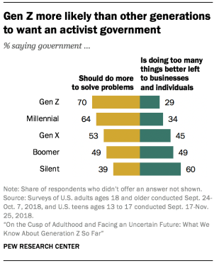

[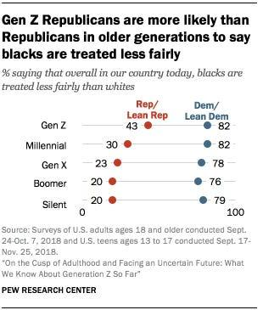](https://substackcdn.com/image/fetch/$s_!wQP_!,f_auto,q_auto:good,fl_progressive:steep/https%3A%2F%2Fsubstack-post-media.s3.amazonaws.com%2Fpublic%2Fimages%2F3561256f-36ac-47f2-8c3d-4ccc6132dd77_309x371.png)

[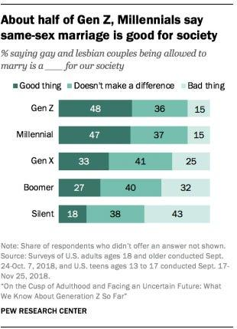](https://substackcdn.com/image/fetch/$s_!oJ37!,f_auto,q_auto:good,fl_progressive:steep/https%3A%2F%2Fsubstack-post-media.s3.amazonaws.com%2Fpublic%2Fimages%2F10031c59-9e2a-439a-838b-b64877d26efb_310x365.png)

I would love to hear your thoughts on this topic! Feel free to drop a comment on substack or email me back.

All the best,

Zoe

P.S. Yes, the capitalization of the subtopics bothered me too.